|  |  |
| --- | --- |
| **Project – External Documentation** |  |
| ISYS6197003  Business Application Development |
| Odd Semester Year 2023 |

# Project Title

NJuice

# Introduction

In this project, students are required to make a GUI to do transactions in the NJuice database. The GUI can be accessed by the customers and admins and based on their roles, their accessibilities and capabilities in the system differ:

1. Customer:

Customers can **Login** to the system with their username and password If they don’t have an account they can head to the **Register** page and create an account. After that, they will be directed to the **Customer Home** scene and will be able to see the contents of their **Cart**. In this scene, customers have the options of adding new items to their cart by clicking the ‘Add new item to Cart’ button, deleting products by clicking ‘Delete from Cart’ button, and checking out the items from the cart by clicking ‘Checkout’ button.

1. Admin:

Admin can login to the system with their username and password. If the admin successfully logs in, they will be directed to the **View Transaction** scene and will be able to see the transaction details by clicking through various transactions. If the admin selects the **Manage Products** navigation bar, they will be able to view, insert, update, and delete products in NJuice’s catalog.

The NJuice application attempts to give administrators control over transactions and product catalog management, as well as customers a convenient and effective platform to manage their carts. The MySQL and JavaFX program improves the application's speed and guarantees a smooth user experience for both administrators and customers.

# Report / Documentation

## Landing Page Navigation Bar

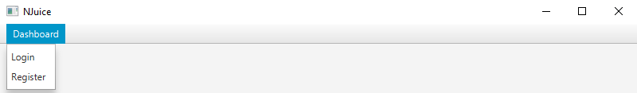

*Figure 1. Landing Page Navigation Bar*

This landing page navigation bar contains ‘Dashboard’ menu (menu) with ‘Login’ menuItem (loginMenu) and ‘Register’ menuItem (registerMenu). If the user clicks the loginMenu, the user will be directed to the login scene. However, if the user clicks the registerMenu, the user will be directed to the register scene.

## Login Scene

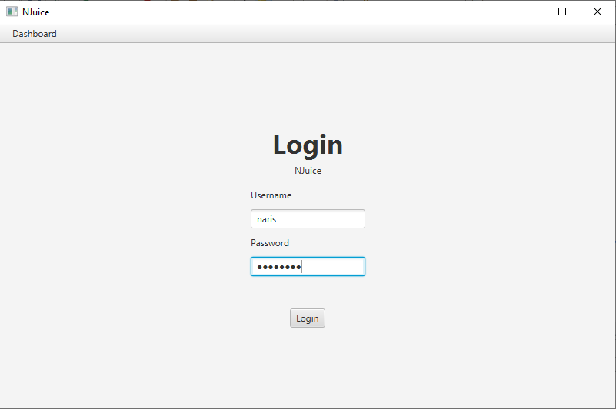

*Figure 2. Login Scene*

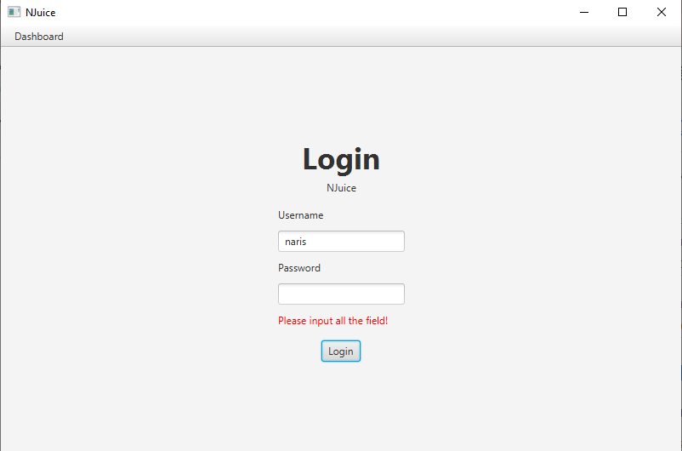

*Figure 3. Login Scene Error Label for Input Field*

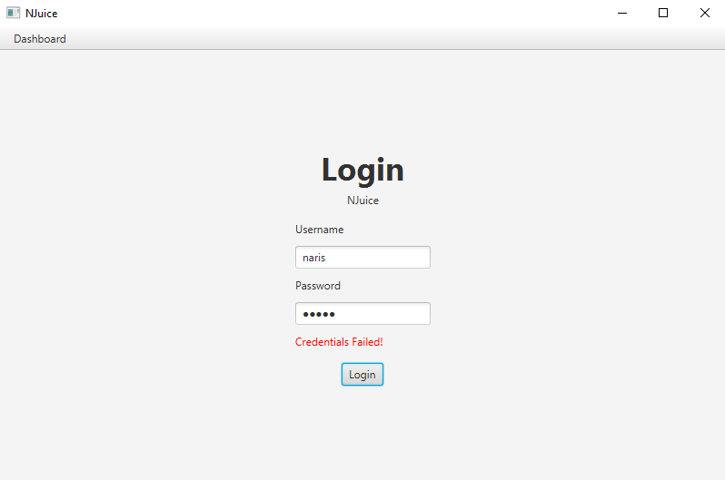

*Figure 4. Login Scene Error Label for Failed Credential*

This login scene contains several components using the layout manager such as BorderPane, GridPane, and VBox. The GridPane (gp) contains usernameLbl, passwordLbl, usernameField, passwordField, and errorLbl. The VBox (vb) will align the components vertically containing loginLbl, njuiceLbl, GridPane, and loginBtn. Then, the BorderPane (bp) positions the VBox at the center and the menuBar with loginMenu and registerMenu at the top.

The event handler is implemented in the loginBtn. If the user logs in as a customer and clicks the ‘Login’ button (loginBtn), the checkRole() method will be called to determine the user’s role as a customer and they will be directed to the customer home scene. However, if the user logs in as an admin and clicks the ‘Login’ button (loginBtn), they will be directed to the admin view transaction scene.

## Register Scene

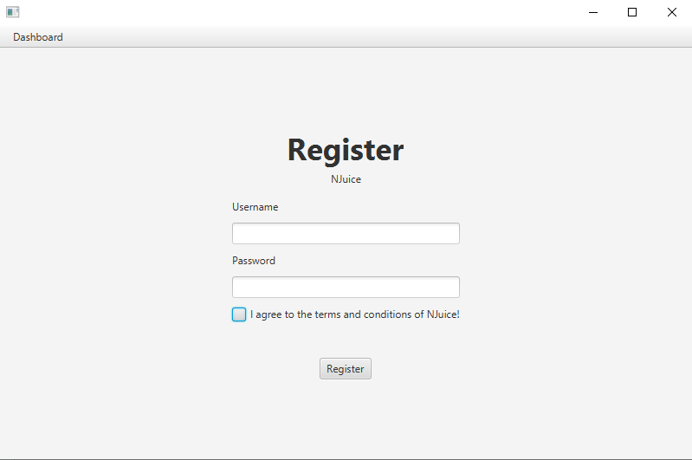

*Figure 5. Register Scene*

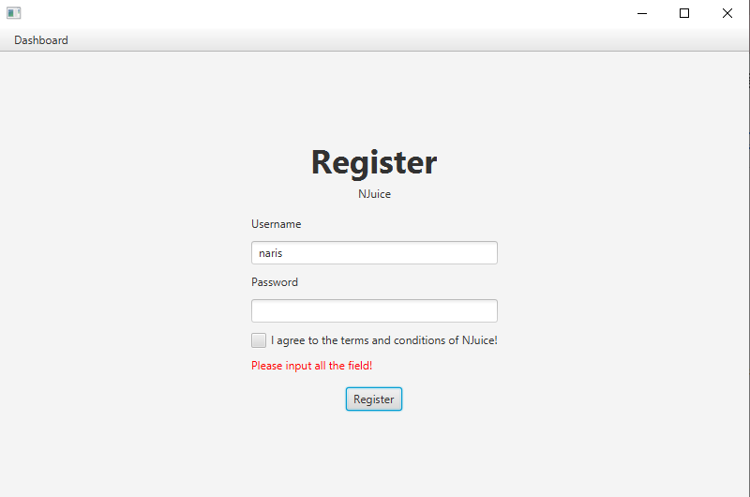

*Figure 6. Register Scene Error Label for Input Field*

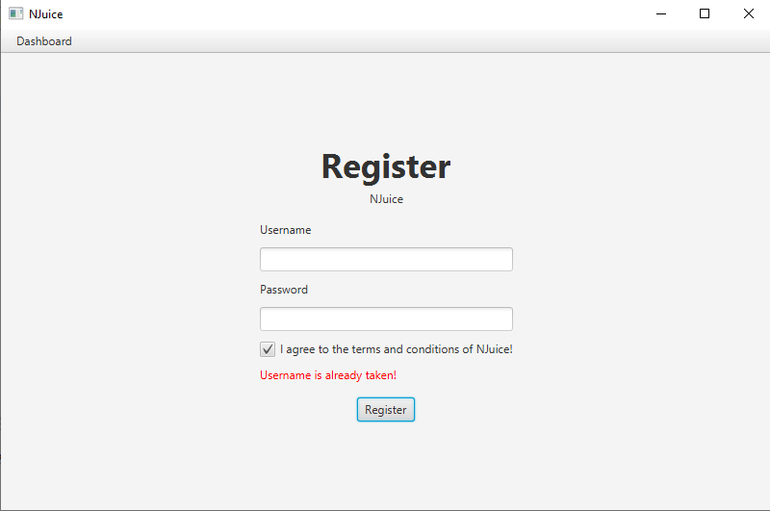

*Figure 7. Register Scene Error Label for not Unique Username*

This register scene contains several components using the layout manager such as BorderPane, GridPane, and VBox. The GridPane contains usernameLbl, passwordLbl, usernameField, passwordField, CheckBox, and errorLbl. The VBox will align the components vertically containing registerLbl, njuiceLbl, GridPane, and registerBtn. Then, the VBox positions the VBox at the center and the menuBar at the top.

The event handler is implemented at the registerBtn. If the user clicks the ‘Register’ button (registerBtn), the program will check whether the conditions are accepted or not and ensure the uniqueness of the username in the database. If the registration is successful, they will be directed to the login scene.

## Customer Navigation Bar



*Figure 8. Customer Navigation Bar*

This customer navigation bar contains a ‘Logout’ button (logoutBtn). If the customer clicks the logoutBtn, the user will be directed to the login scene.

## Customer Home Scene

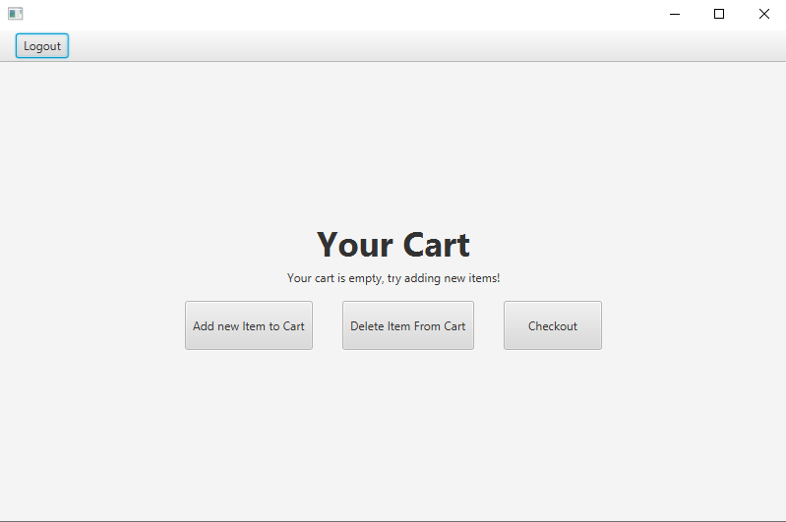

*Figure 9. Customer Home*

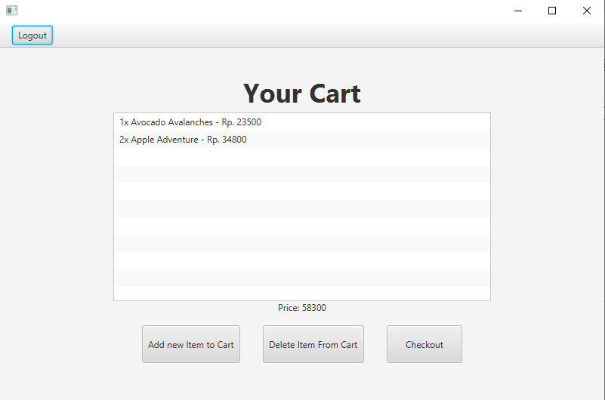

*Figure 10. Customer Home after the user filled their cart*

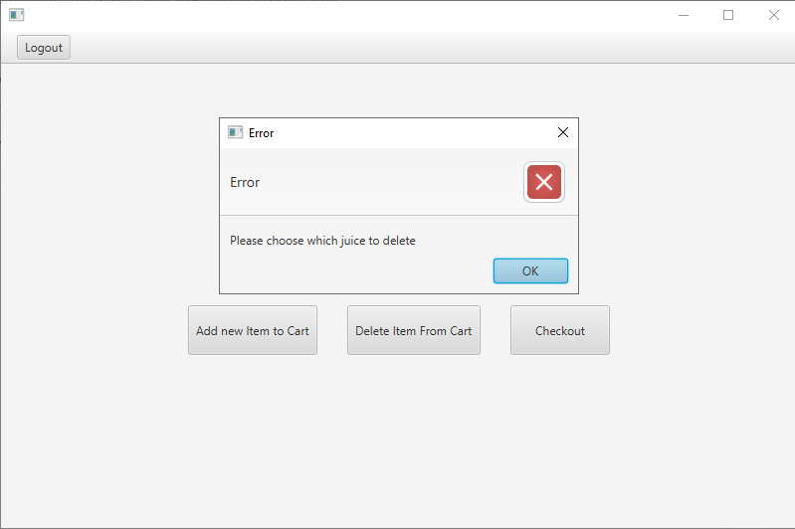

*Figure 11. Customer Home Error alert if no juice is selected for delete*

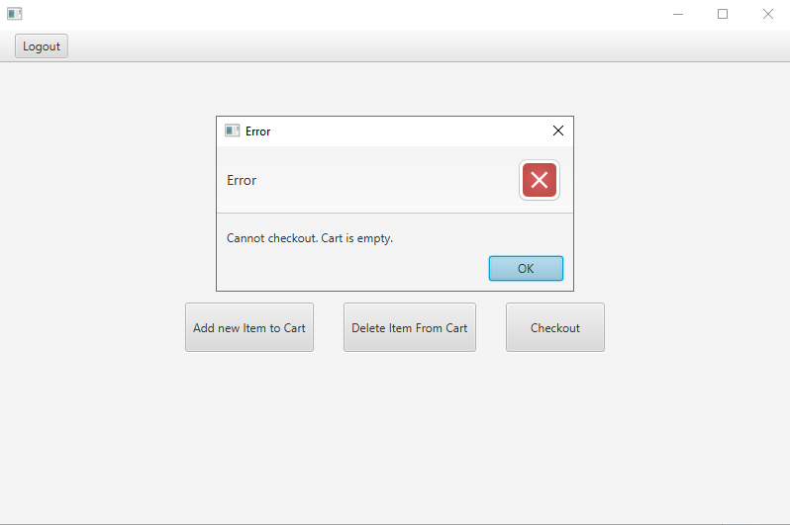

*Figure 12. Customer Home Error alert if no juice in cart for checkout*

This customer home scene contains several components using the layout manager such as BorderPane, GridPane, and VBox. The BorderPane (bp) as the main layout container consists of menuBar at the top and VBox at the center. The VBox (vb) aligns the components vertically including yourCartLbl, emptyLbl, buttons, and ListView to display the customer's cart after adding a new item. The GridPane (gp) arranges the newBtn, deleteBtn, and checkoutBtn horizontally with specific columns.

The event handlers are implemented in the newBtn, deleteBtn, and checkoutBtn. If the customer clicks the ‘Add new Item to Cart’ button (newBtn), they will be directed to the customer to add a new item scene. If the customer clicks one of the items and clicks the ‘Delete Item From Cart’ button deleteBtn, the selected item will be deleted from the cart list. If the customer clicks the ‘Checkout’ button (checkoutBtn), they will be directed to the customer checkout scene.

## Customer Add New Item Scene

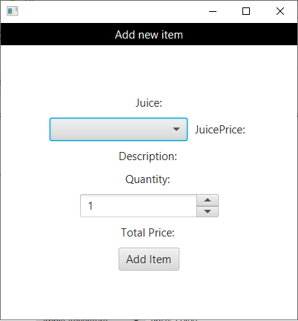

*Figure 13. Customer Add New Item Pop-Up*

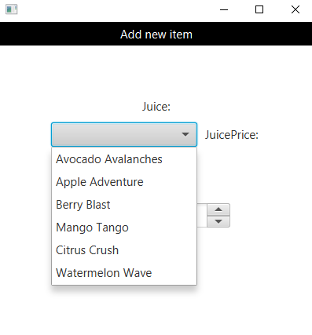

*Figure 14. Item Combo Box Options depends on the Product in the Database*

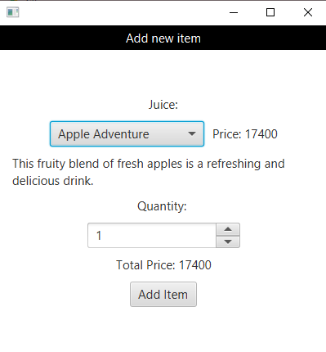

*Figure 15. After user choose an option, price, description and total price will be updated*

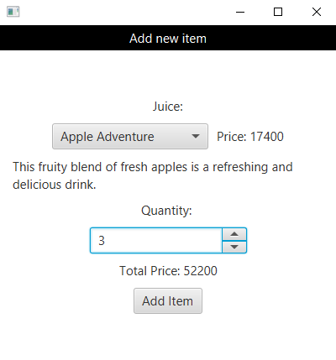

*Figure 16. If the quantity is changed, the total price will also change*

This customer add new item scene contains several components using the layout manager such as BorderPane, FlowPane, and VBox. The BorderPane (bpAddItem) that contains title bar and label. The VBox (vbAddItem) is setCenter containing juiceLbl, priceLbl, descLbl, qtyLbl, totPriceLbl, productBox, qtySpinner, and addItemBtn.

The event handler is implemented in the addItemBtn. If the customer clicks the ‘Add Item’ button (addItemBtn), the pop windows will be closed and the item will be added to the customer’s cart list.

## Customer Checkout Scene

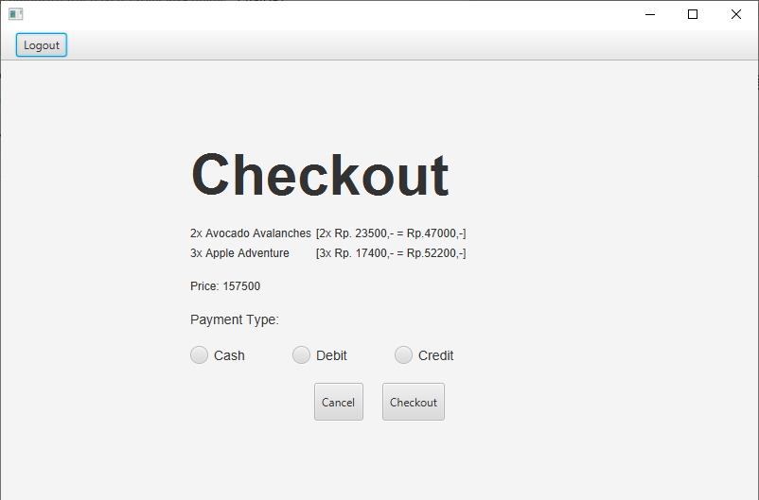

*Figure 17. Checkout Scene*

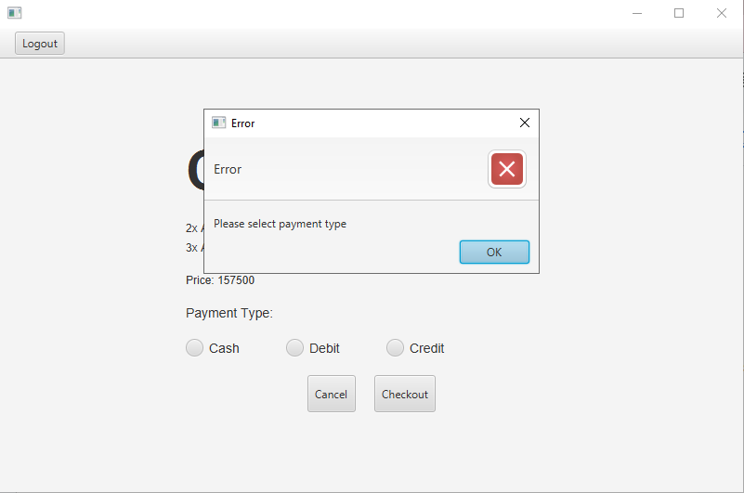

*Figure 18. Checkout Scene Error message if payment is not selected*

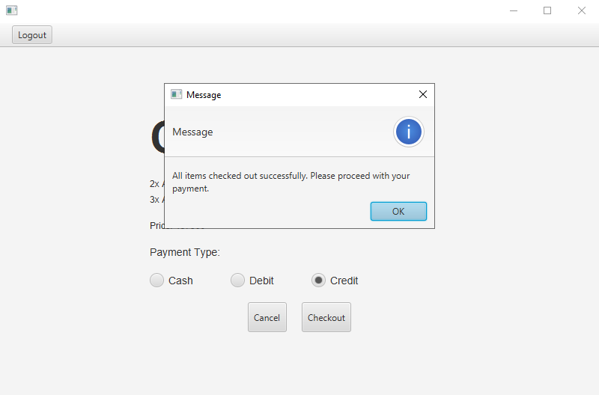

*Figure 19. Checkout Scene Information message after successfully checkout all item*

This customer checkout scene contains several components using the layout manager such as BorderPane, GridPane, FlowPane, HBox. The BorderPane contains menuBar, menu, and logoutBtn. The HBox contains cancleButton and checkoutButton. The FlowPane contains cashRadioButton, debitCardRadioButton, and creditCardRadioButton. Then, the GridPane as the main content contains titleLbl, cartLbl, priceLbl, typeLbl, radioBtnPane, and buttonBox.

The event handlers are implemented in the logoutBtn, cancelButton, and checkoutButton. If the customer clicks the ‘Cancel’ button (CancelButton), they will be directed to the customer home scene. If the customer clicks the ‘Checkout’ button (checkoutButton), the transaction will be saved to the database. If the customer clicks the ‘Logout’ button (logoutBtn), the session will be cleared and open the login scene.

## Admin Navigation Bar

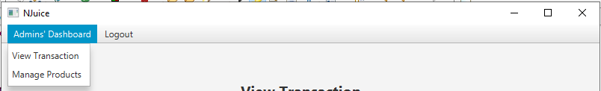

*Figure 20. Admin Navigation Bar option if the menu dashboard is selected*

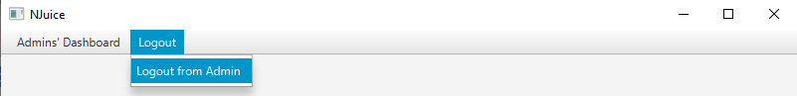

*Figure 21. Admin Navigation Bar option if the menu logout is selected*

This admin navigation bar contains ‘Admin’s Dashboard’ menu (menu) with ‘View Transaction’ menuItem (viewMenu) and ‘Manage Products’ menuItem (manageMenu). If the admin clicks the viewMenu, the admin will be directed to the admin view transaction scene. However, if the admin clicks the manageMenu, the admin will be directed to the admin manage product scene. Also, this customer navigation bar contains ‘Logout’ menu (menu2) with ‘Logout from Admin’ menuItem (logoutMenu). If the admin clicks the logoutMenu, the admin will be directed to the login scene.

## Admin View Transaction Scene

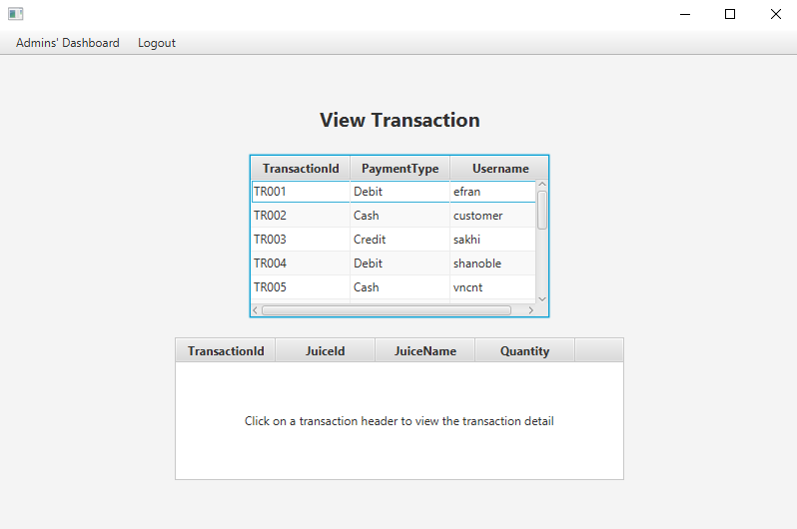

*Figure 22. Admin View Transaction Scene*

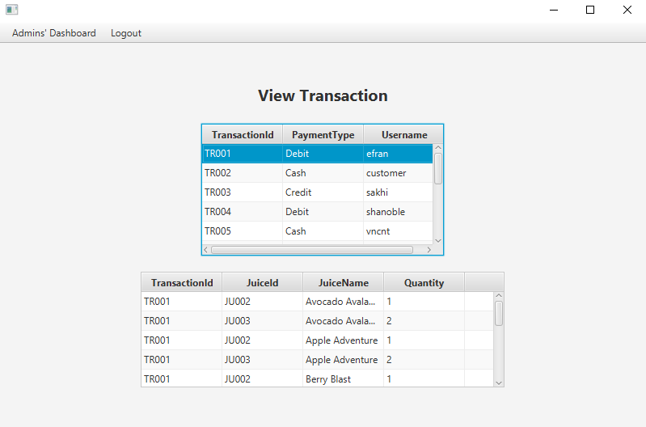

*Figure 23. If the transaction is clicked, the detail appears in the detail table*

This admin view transaction scene contains several components using the layout manager such as BorderPane and VBox. The BorderPane as the main layout container contains menuBar with viewMenu and manageMenu. The VBox (vb) is setCenter containing TableView with transHeaderTable and transDetailTable.

The event handler is implemented in the showTransDetail() method. If the admin clicks on one of the lists in the transHeaderTable, the transDetailTable containing ‘TransactionId’ column (transIdColumn2), ‘JuiceId’ column (juiceIdColumn), ‘JuiceName’ column (juiceNameColumn), and ‘Quantity’ column (qtyColumn) will be loaded dynamically according to the selected transaction header.

## Admin Manage Product Scene

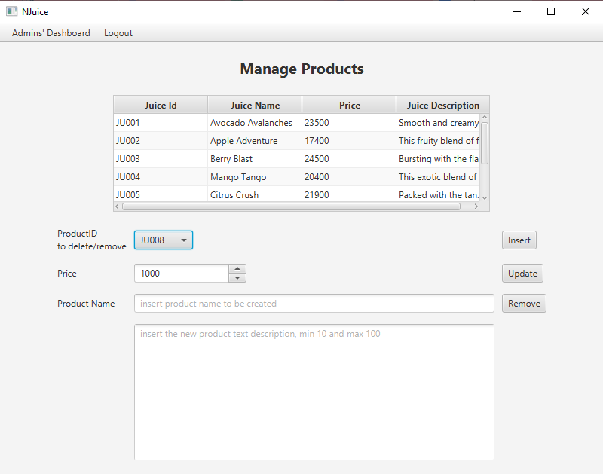

*Figure 24. Manage Product Scene*

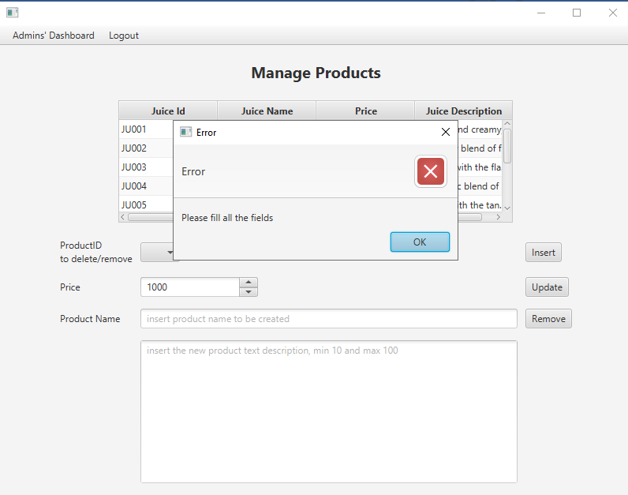

*Figure 25. Manage Product Scene Error message if the data needed is not sufficient*

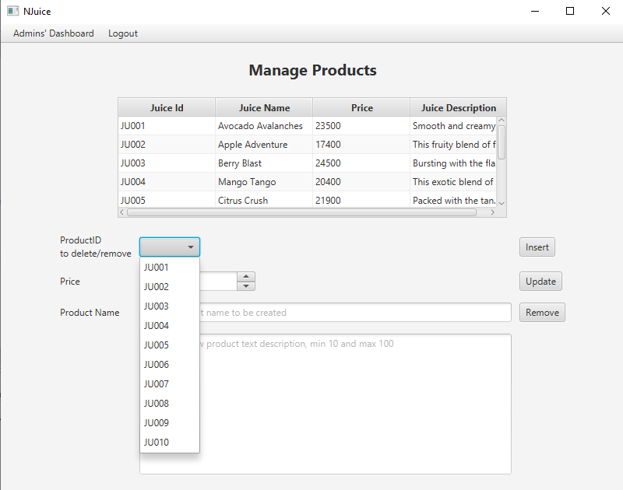

*Figure 26. Product Id in the combo box must matches with juices id in the database*

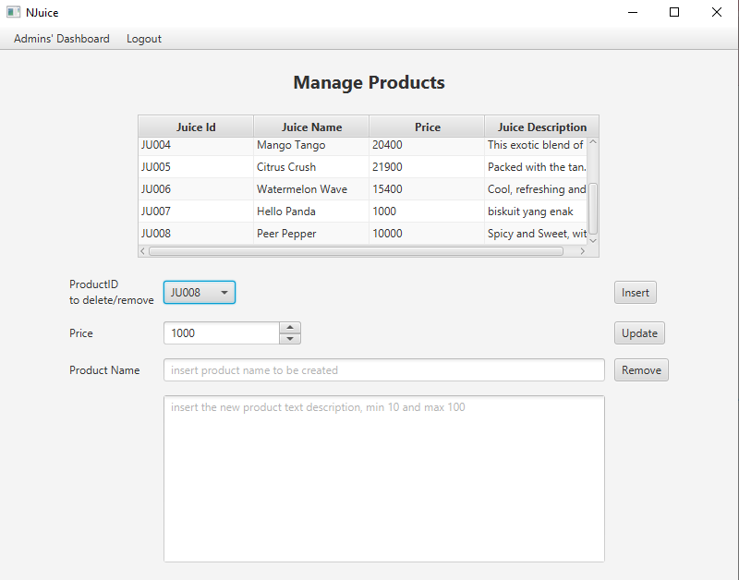

*Figure 27. Table example after a new juice is inserted*

This admin manage product scene contains several components using the layout manager such as GridPane and BorderPane. The BorderPane is setTop containing a GridPane (titleContainer) to display the title label (titleLbl1). The GridPane (tableContainer) is setCenter that displays a TableView (msJuiceTable) for managing product information. The other GridPane (gp) is setBottom that consists of mngLbID, mngLbPrice, mngLbPName, idBox, priceSpinner, mngPName, mngDescTf, insertBtn, updateBtn, and removeBtn.

The event handlers are implemented in the insertBtn, updateBtn, and removeBtn. To input a new product to the system the Admin can simply fill in the required details to the fields and then click the ‘Insert’ button (insertBtn), the input within the fields will be saved in the database and a new JuiceID will be generated . To update data within the table the Admin has to click on one of the entries in the table and it will be displayed in the fields, front there the Admin can make changes and click the ‘Update’ button (updateBtn) when the adjustment is correct. Then the updated data will be saved in the database. To remove products from the table the Admin can click on one of the entries then click the ‘Remove’ button (removeBtn) and the product will be removed.

# Reference

* + <https://www.tutorialspoint.com/javafx/javafx_event_handling.htm>
  + <https://www.tutorialspoint.com/how-to-implement-actionevent-using-method-reference-in-javafx>
  + <https://www.geeksforgeeks.org/javafx-combobox-with-examples/>
  + <https://docs.oracle.com/javase/8/javafx/api/javafx/scene/control/ToggleGroup.html>

# Group Member

* + 2602078524 – Beverly Dennis
  + 2602091431 – Keisha Dean Tan
  + 2602086816 – Nariswari Afiyah Emiliani
  + 2602077931 – Vania Cyrilla